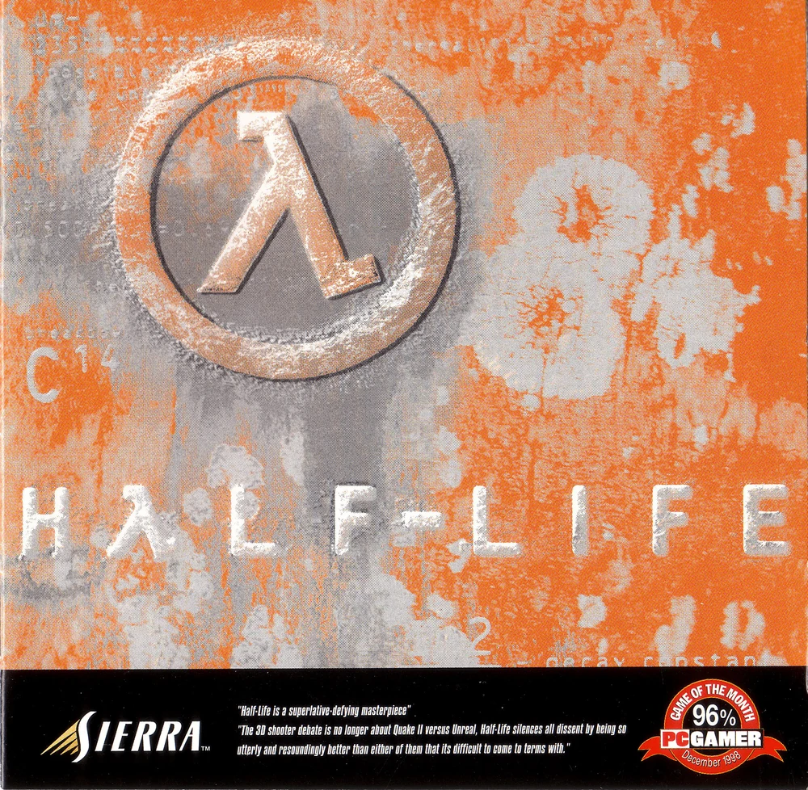

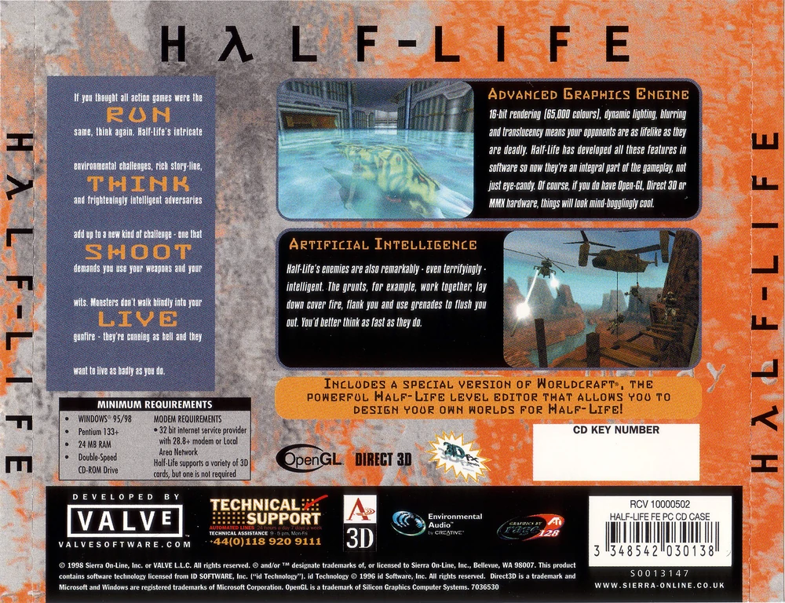

_______________________________

**Album:** Half-Life Original Soundtrack

**Artist:** Kelly Bailey / Ben Houge

**Date:** 1998

**Genre:** Soundtrack / Game / Rock

**Ripped & Encoded With:** FairStars CD Ripper using FLAC compression level 8

**Tracks**

_______________________________

Half-Life Menu Music (PS2 Version)

01 - Adrenaline Horror

02 - Black Mesa Inbound (Vague Voices)

03 - Klaxon Beat

04 - Echoes of a Resonance Cascade (Space Ocean)

05 - Zero Point Energy Field (Cavern Ambience)

06 - Stinger One (Apprehensive Short)

07 - Stinger Two (Bass String Short)

08 - Neutrino Trap (Hurricane Strings)

09 - Lambda Core (Diabolical Adrenaline Guitar)

10 - Valve Theme (Long Version)

11 - Nepal Monastery

12 - Alien Shock

13 - Sirens in the Distance

14 - Something Secret Steers Us (Nuclear Mission Jam)

15 - Stinger Three (Scared Confused Short)

16 - Tau-9 (Drums & Riffs)

17 - Hard Technology Rock

18 - Negative Pressure (Steam in the Pipes)

19 - Escape Array (Electric Guitar Ambience)

20 - Dirac Shore (Dimensionless Deepness)

21 - Military Precision

22 - Jungle Drums

23 - Singularity (Traveling Through Limbo)

24 - Freedom (Closing Theme)

25 - Xen Relay (Threatening Short)

26 - Stinger Four (Dark Piano Short)

27 - Stinger Five (Sharp Fear Short)

28 - Lambda Core (Diabolical Adrenaline Guitar) [Alpha V0.52]

29 - Neutrino Trap (Hurricane Strings) [Alpha V0.52]

_______________________________